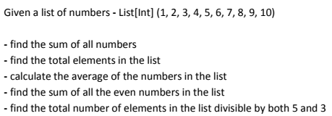

**Screenshot of Program:-**

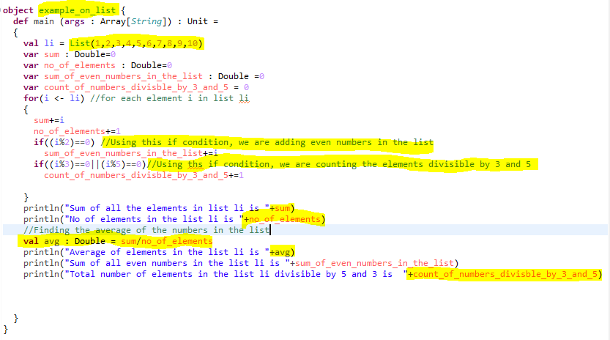

**SAMPLE OUTPUT:-**

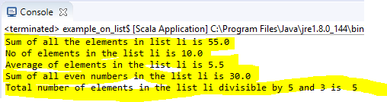

**PROGRAM CODE:-**

**object** example_on_list {

**def** main (args : Array[*String*]) : Unit =

{

**val** li = List(1,2,3,4,5,6,7,8,9,10)

**var** sum : Double=0

**var** no_of_elements : Double=0

**var** sum_of_even_numbers_in_the_list : Double =0

**var** count_of_numbers_divisble_by_3_and_5 = 0

**for**(i <- li) //for each element i in list li

{

sum+=i

no_of_elements+=1

**if**((i%2)==0) //Using this if condition, we are adding even numbers in the list

sum_of_even_numbers_in_the_list+=i

**if**((i%3)==0||(i%5)==0)//Using ths if condition, we are counting the elements divisible by 3 and 5

count_of_numbers_divisble_by_3_and_5+=1

}

println("Sum of all the elements in list li is "+sum)

println("No of elements in the list li is "+no_of_elements)

//Finding the average of the numbers in the list

**val** avg : Double = sum/no_of_elements

println("Average of elements in the list li is "+avg)

println("Sum of all even numbers in the list li is "+sum_of_even_numbers_in_the_list)

println("Total number of elements in the list li divisible by 5 and 3 is "+count_of_numbers_divisble_by_3_and_5)

}

}